1.

Find the set of prime factors of 12.
A.
{3}
B.
{2, 3}
C.
{3, 4}
D.
{2, 6}
E.
{2,3,4,6,12}

2.

If P = {7, 11, 13} and Q = {9, 11, 13}. Find P U Q.
A.
{7}
B.
{9}
C.
{7, 9}
D.
{7, 9, 11}
E.
{7, 9, 11, 13}

3.

In the diagram, set Q has 30 members and set T has 25 members. Q ∩ T has 10 members.
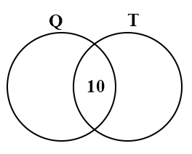
Find the number of members of Q U T
A.
35
B.
45
C.
55
D.
65
E.
75

4.

Find the value of
6
1
4
−
−
−
√
A.
5.0
B.
4.9
C.
2.5
D.
2.4
E.
1.2

5.

Convert 39_{ten} to a base five numeral.
A.
100111
B.
1110
C.
234
D.
124
E.
103

6.

Find the least whole number which must be added to 207 to make it divisible by 17
A.
0
B.
3
C.
13
D.
14
E.
15

7.

Simplify 2 x (3
1
3
+ 1
1
6
)
A.
2
1
3
B.
4
1
4
C.
6
2
3
D.
8
E.
9

8.

If 8.51 ÷ 2.3 = 3.7, find the value of 85.1 ÷ 2.3
A.
0.037
B.
0.37
C.
3.7
D.
37
E.
370

9.

Express 0.625 as a fraction in its lowest term.
A.
7
8
B.
3
4
C.
5
8
D.
1
2
E.
1
3

10.

An amount of money is shared between Kofi and Ama in the ratio 3 : 5. If Ama received ₵4,650.00, what is Kofi's share?
A.
₵930.00
B.
₵1,550.00
C.
₵1,743.75
D.
₵2,790.00
E.
₵2,906.25

11.

If $1.00 = ₵340.00, what was the cedi value of an article which cost $6.50?
A.
₵6,630.00
B.
₵2,380.00
C.
₵2,210.00
D.
₵346.50
E.
₵333.50

12.

Find the simple interest on ₵28,000.00 at 3
1
2
% per annum for 6 months.
A.
₵490.00
B.
₵560.00
C.
₵980.00
D.
₵4,000.00
E.
₵5,880.00

13.

The bar chart shows the distances of 5 villages, P, Q, R, S and T from a market town.
Use it to answer the question below.
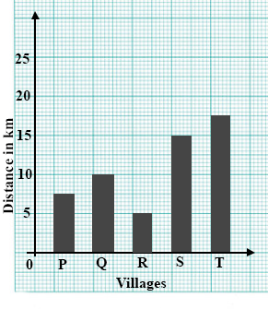
Which village is farthest from the market town?
A.
P
B.
Q
C.
R
D.
S
E.
T

14.

The bar chart shows the distances of 5 villages, P, Q, R, S and T from a market town.
Use it to answer the question below.
How much farther is village Q than village R from the market town?
A.
2 km
B.
3 km
C.
4 km
D.
5 km
E.
6 km

15.

There are 20 beads in a box. Some are red and some green. The chance that one bead taken at random from the box is red is
1
4
. Find the number of red beads in the box.
A.
16
B.
15
C.
10
D.
5
E.
4

16.

A bag contains 12 mangoes of which 4 are not ripe. What is the chance of picking at random a ripe mango from the bag?
A.
1
8
B.
1
4
C.
1
3
D.
1
2
E.
2
3

17.

Find the value of p² – 6p + 9 when p = -2
A.
–7
B.
1
C.
12
D.
13
E.
25

18.

If x = 2, find the value of q in the equation 3x – 4 = x + q.
A.
8
B.
1
C.
0
D.
–1
E.
–8

19.

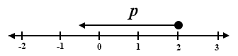
Which of the following inequalities is shown on the number line above, where p is a real number?
A.
p ≥ 2
B.
p > 2
C.
p = 2
D.
p ≤ 2
E.
p < 2

20.

Use the mapping below to answer the question below
-2 | -1 | 0 | 2 | 3 | 4 | ...... | x
↓ | ↓ | ↓ | ↓ | ↓ | ↓ |  | ↓
y | -1 | 1 | 5 | 7 | 9 | ...... | 21
Find the value of x
A.
–7
B.
5
C.
6
D.
7
E.
10

21.

Use the mapping below to answer the question below
-2 | -1 | 0 | 2 | 3 | 4 | ...... | x
↓ | ↓ | ↓ | ↓ | ↓ | ↓ |  | ↓
y | -1 | 1 | 5 | 7 | 9 | ...... | 21
Find the value of y
A.
3
B.
1
C.
–1
D.
–3
E.
-5

22.

In the diagram below, find the bearing of P from Q
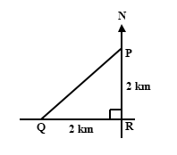
A.
045°
B.
090°
C.
135°
D.
180°
E.
270°

23.

A polygon has 10 sides. Which of the following gives the sum of its interior angles?
A.
2 x 180°
B.
4 x 180°
C.
6 x 180°
D.
8 x 180°
E.
10 x 180°

24.

The diagram shows the conversion graph for miles and kilometres.
Use it to answer the question below
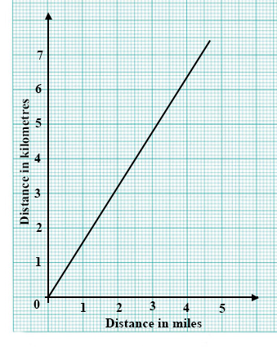
Find in kilometres, the equivalent of 4 miles.
A.
2.5
B.
3
C.
3.5
D.
6
E.
6.4

25.

The diagram shows the conversion graph for miles and kilometres.
Use it to answer the question below
Express 4 kilometres in miles.
A.
6.4
B.
6
C.
3.5
D.
3
E.
2.5

26.

The diagram below is a right-angled triangle.
Use it to answer the question below
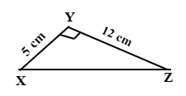
Find |XZ|
A.
2.4 cm
B.
7 cm
C.
13 cm
D.
17 cm
E.
60 cm

27.

The diagram below is a right-angled triangle.
Use it to answer the question below
Find tan ∠YXZ
A.
5
13
B.
5
12
C.
12
13
D.
12
5
E.
13
5

28.

The diagram below shows two points P and Q in the number plane. Find the vector PQ.
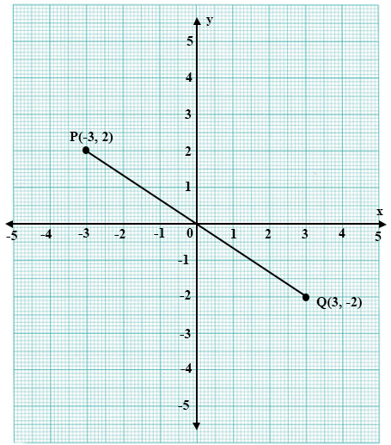
A.
(
6
4
)
B.
(
6
-4
)
C.
(
-6
4
)
D.
(
4
-6
)
E.
(
-4
-6
)

29.

Find the length of the vector p =
(
-5
12
)
A.
7
B.
10
C.
13
D.
17
E.
25

30.

In the diagram, square P¹Q¹R¹S¹ is an enlargement of square PQRS from centre O. The area of PQRS is 4 cm² and the area of P¹Q¹R¹S¹ is 9 cm².
Find the scale factor of the enlargement.
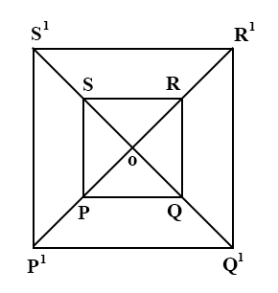
A.
2
3
B.
4
9
C.
1
1
2
D.
-
2
3
E.
2
1
4

31.

The volume of a cube is 27 cm³. Find the area of one of its faces.
A.
3 cm²
B.
6 cm²
C.
9 cm²
D.
18 cm²
E.
54 cm²

32.

A cylinder is of height 3 cm and radius 2 cm. Find its curved surface area.
[Take π = 3.142]
A.
7 cm²
B.
12 cm²
C.
18 cm²
D.
38 cm²
E.
54 cm²

33.

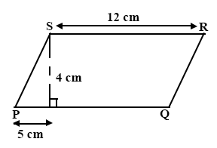
Find the area of the parallelogram PQRS
A.
20 cm²
B.
21 cm²
C.
48 cm²
D.
60 cm²
E.
240 cm²

34.

If one-third of a number is added to one-fifth of the same number, the result is 8. Find the number.
A.
3
B.
5
C.
15
D.
40
E.
45

35.

If 1 : x is equivalent to 6
1
4
: 25, find x.
A.
4
B.
5
C.
6.25
D.
24
E.
100

36.

Express
3
8
as a percentage.
A.
0.373%
B.
12%
C.
25%
D.
37
1
2
%
E.
40%

37.

Akosua buys 480 pineapples for ₵24,000.00. She sells all the pineapples for ₵28,000.00. Find her profit percent.
A.
13.9%
B.
16.7%
C.
20%
D.
40%
E.
83.3%

38.

How many edges has a cuboid?
A.
4
B.
6
C.
8
D.
10
E.
12

39.

The pie chart shows the distribution of crops on a farm of area 250 hectares.
Use it to answer the question below.
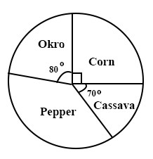
Find the area of the plot with corn.
A.
48.6
B.
55.3
C.
62.5 ha
D.
83.3 ha
E.
125.0 ha

40.

The pie chart shows the distribution of crops on a farm of area 250 hectares.
Use it to answer the question below.
What fraction of the farm is planted with pepper?
A.
1
3
B.
1
4
C.
1
5
D.
2
9
E.
7
32

